1. Write a JAVA Program to find all the Armstrong Numbers from a given range.

Code :

import java.util.Scanner;

public class ArmstrongNumber {

public static void main(String[] args) {

Scanner sc = new Scanner(System.in);

int number = 371, originalNumber, remainder, result = 0;

System.out.println("Enter the number to be checked :");

number=sc.nextInt();

originalNumber = number;

while (originalNumber != 0)

{

remainder = originalNumber % 10;

result += Math.pow(remainder, 3);

originalNumber /= 10;

}

if(result == number)

System.out.println(number + " is an Armstrong number.");

else

System.out.println(number + " is not an Armstrong number.");

}

}

Output :

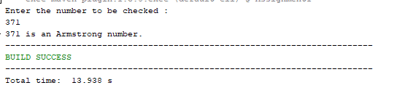

1. Write a JAVA Program to calculate the Sum of Series (1+X2+X3+X4+…………).

Code :

import java.util.Scanner;

public class SumofSeries {

public static void main(String[] args) {

int x, n, sum=0;

Scanner sc = new Scanner (System.in);

System.out.println("Enter the value of X :");

x=sc.nextInt();

System.out.println("Enter the value of N :");

n=sc.nextInt();

sum+=1;

for (int i=2;i<=n;i++){

sum+=x\*i;

}

System.out.println("The Sum is : "+sum);

}

}

Output :

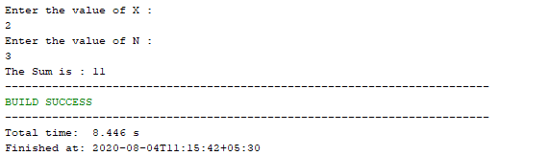

1. Write a JAVA Program to print the first n Fibonacci numbers using Command Line argument.

Code :

public class FibonacciSeries {

public static void main(String[] args) {

int n = 10, t1 = 0, t2 = 1;

n = Integer.parseInt(args[0]);

System.out.print("First " + n + " terms: ");

for (int i = 1; i <= n; ++i)

{

System.out.print(t1 + " + ");

int sum = t1 + t2;

t1 = t2;

t2 = sum;

}

}

}

Output :

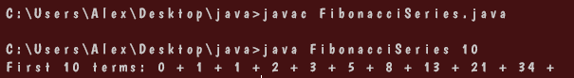

1. Write a JAVA Program to print all prime numbers from the user define range using Command Line argument.

Code :

public class PrintPrime {

public static void main(String[] args) {

int a=0, b=0, i, j, flag;

a=Integer.parseInt(args[0]);

b=Integer.parseInt(args[1]);

System.out.printf("\nPrime numbers between %d and %d are: ", a, b);

for (i = a; i <= b; i++) {

if (i == 1 || i == 0)

continue;

flag = 1;

for (j = 2; j <= i / 2; ++j) {

if (i % j == 0) {

flag = 0;

break;

} }

if (flag == 1)

System.out.println(i);

} } }

Output :

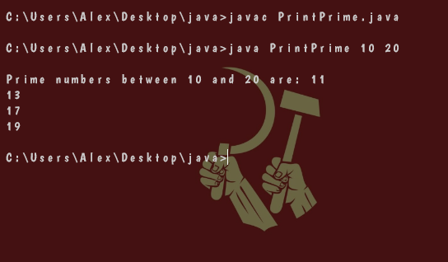

1. Write a JAVA Program to find GCD of any two numbers.

Code :

public class GCD {

public static void main(String[] args) {

int num1=0, num2=0;

num1=Integer.parseInt(args[0]);

num2=Integer.parseInt(args[1]);

while (num1 != num2) {

if (num1 > num2)

num1 = num1 - num2;

else

num2 = num2 - num1;

}

System.out.printf("GCD of the given numbers is: "+ num2);

}

}

Output :

